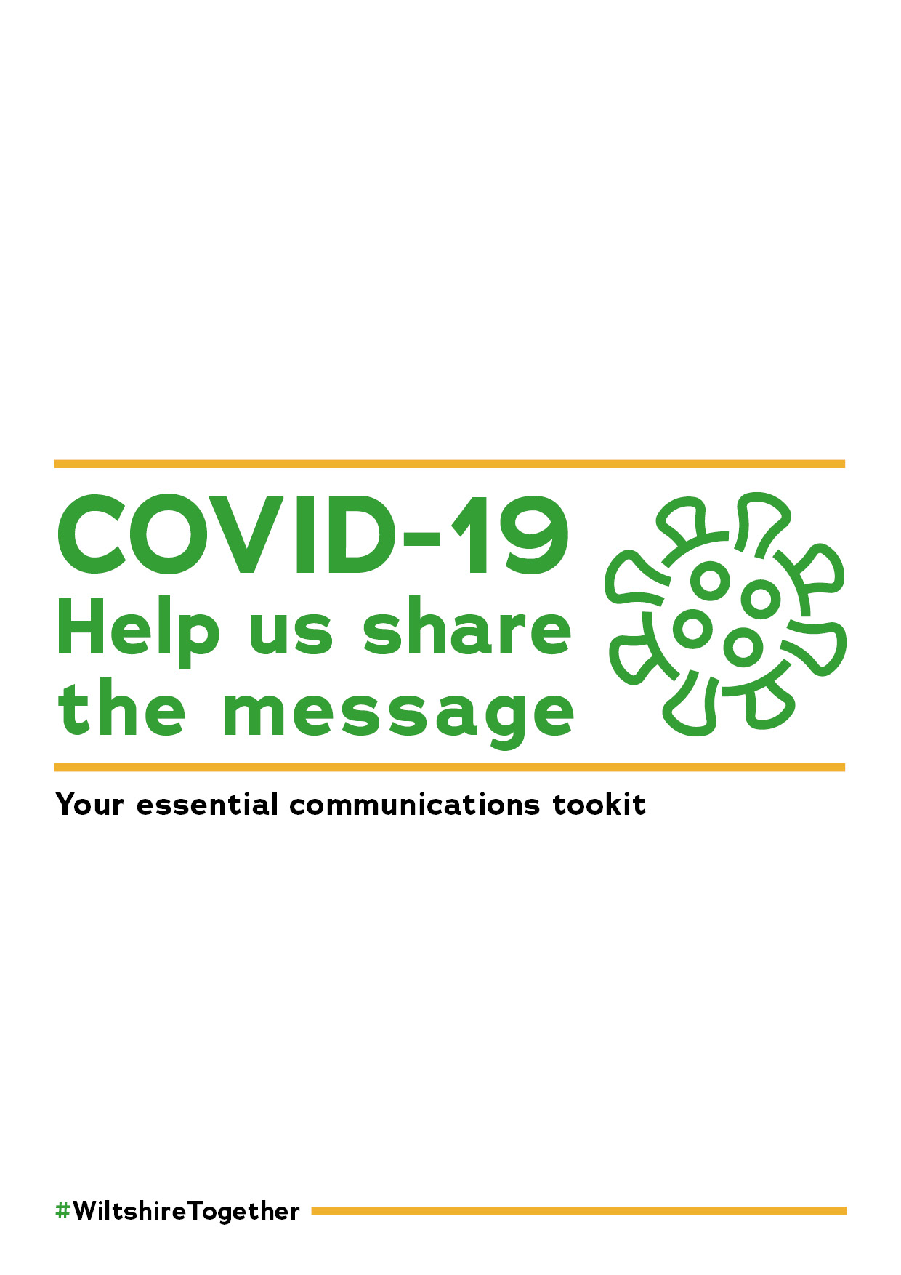
Introduction
With so much information available from a variety of sources on
COVID-19, and with recent changes announced by the government, we thought it would be useful to bring as much of it together as possible and share the key messages with you, so that should you get any queries from residents, employees or your networks, you have the very latest information to hand. To ensure that together Wiltshire maintains low transmission rates of COVID-19 we must share messages as widely as possible.
The information included in this toolkit below has been written in a way that means you could just copy and paste it to include in any local newsletters or share through any channels you may wish to.
Given the fast-moving nature of the situation, please bear in mind that the information could change.
If you have any additional questions, please contact the communications team.

▬▬▬▬▬▬▬▬▬▬▬▬▬▬▬▬▬▬▬▬▬▬
Latest government measures and key messages
Hands, Face, Space

The ‘Hands, Face, Space’ campaign urges you to continue to wash your hands, cover your face and make space to control infection rates and avoid a second peak.
Coronavirus (COVID-19) is an easy virus to kill when it is on skin. It is essential that everyone washes their hands more often, using soap and water for at least 20 seconds.

It is critical that everybody observes the following key behaviours:
- HANDS - Wash your hands regularly and for at least 20 seconds.
- FACE - Cover your face in enclosed spaces, especially where social distancing may be difficult and where you will come into contact with people you do not normally meet.
- SPACE - Stay two metres apart where possible, or one metre with extra precautions in place.

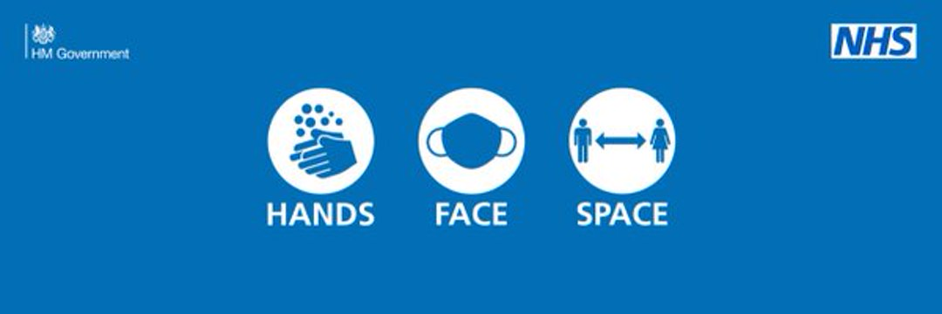

The Rule of Six
The rules on how many people can meet have been simplified.
The only rule that you now need to remember is to not participate in social gatherings of more than six people in any setting, indoors or outdoors.
In England children are not exempt from the rule of six.
This rule replaces the previous ban on participating in gatherings of more than 30 and the guidance on allowing two households to meet indoors.
The new rule means that, apart from a set of limited exemptions including work and education, any social gatherings of more than six people will be against the law.
Police will be able to disperse any such gatherings and fine individuals involved £200, doubling up to a maximum of £6,400.
It remains the case that organisers and facilitators of larger gatherings of more than 30 people – such as unlicensed music events – can be subject to fines of up to £10,000.
Venues following COVID-19 secure guidelines – such as places of worships, gyms, restaurants and other hospitality venues – can still hold more than six people in total. But within those venues, there must not be individual groups larger than six, and groups must not mix socially or form larger groups.
View the full list of exemptions
No more than 15 people can legally attend a marriage or civil partnership, even where this can be safely accommodated with social distancing in a COVID-19 secure venue.This is the maximum number for all attendees at the event, including the couple and guests. Anyone working is not included as part of the legal limit.
From 28 September, receptions and other celebrations for weddings and civil partnerships can continue to take place, but only in the form of a sit-down meal in a COVID-19 secure venue. No more than 15 people may attend. Such receptions must not take place in people’s private homes (or adjoining outdoor spaces like gardens), given that these will not have the same COVID-19 secure measures in place.
More information on the wedding guidance.
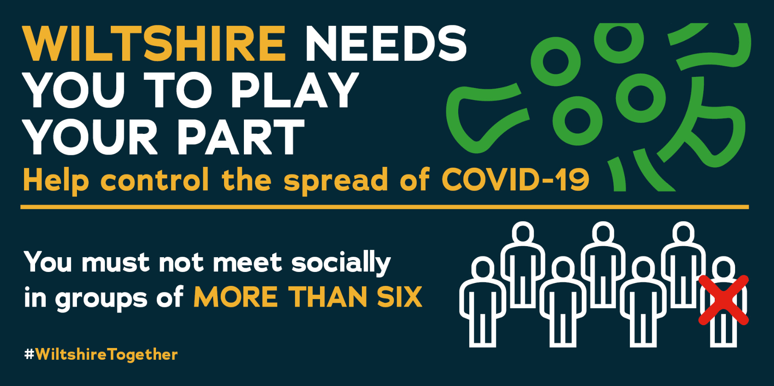

How the new rules on gatherings will be enforced
The police will be able to enforce new legal limits on gatherings, those that break them could face a fine (fixed penalty notice) of £200, doubling for further breaches up to a maximum of £6,400.
Hospitality businesses are also required to ensure there are no unlawful gatherings in their premises. The majority of businesses are responsible and are taking the necessary steps to be COVID-19 Secure, but for those businesses who won’t take these steps, egregious breaches will be enforced. Any breaches are liable of a fine of up to £10,000. These legal requirements will be extended to extra businesses in the leisure and entertainment sectors from 28 September.
Anyone holding a gathering of more than 30 (such as a rave or house party) could face a £10,000 fine.
▬▬▬▬▬▬▬▬▬▬▬▬▬▬▬▬▬▬▬▬▬▬
Face Coverings
In England, you must wear a face covering in the following indoor settings (a list of examples for each is included in the brackets):
- public transport (aeroplanes, trains, trams and buses (customers by law, drivers only advised to)
- taxis and private hire vehicles (customers by law, drivers only advised to)
- transport hubs (airports, rail and tram stations and terminals, maritime ports and terminals, bus and coach stations and terminals)
- shops and supermarkets (places which offer goods or services for retail sale or hire)
- shopping centres (malls and indoor markets)
- auction houses
- premises providing hospitality (bars, pubs, restaurants, cafes), except when seated at a table to eat or drink (see exemptions)
- post offices, banks, building societies, high-street solicitors and accountants, credit unions, short-term loan providers, savings clubs and money service businesses
- premises providing personal care and beauty treatments by law from 24 September (hair salons, barbers, nail salons, massage centres, tattoo and piercing parlours)
- premises providing veterinary services
- visitor attractions and entertainment venues (museums, galleries, cinemas, theatres, concert halls, cultural and heritage sites, aquariums, indoor zoos and visitor farms, bingo halls, amusement arcades, adventure activity centres, indoor sports stadiums, funfairs, theme parks, casinos, skating rinks, bowling alleys, indoor play areas including soft-play areas)
- libraries and public reading rooms
- places of worship
- funeral service providers (funeral homes, crematoria and burial ground chapels)
- community centres, youth centres and social clubs
- exhibition halls and conference centres
- public areas in hotels and hostels
- storage and distribution facilities
Face coverings should also be worn in indoor places not listed above where social distancing may be difficult and where people will come into contact with people they do not normally meet.
Face coverings are needed in NHS settings, including hospitals and primary or community care settings, such as GP surgeries. They are also advised to be worn in care homes.
If you are already exempt from the existing face covering obligations, such as because of an underlying health condition, you will continue to be exempt from these new obligations.

Guidance stating that face coverings and visors should be worn in close contact services has now become law.

Read the full government guidance on face coverings

When face coverings do not need to be worn
In settings where face coverings are required, there are some circumstances where you may not be able to wear them. Please be mindful and respectful of such circumstances, noting that some people are less able to wear face coverings, and that the reasons for this may not be visible to others.
This includes (but is not limited to):
- children under the age of 11 (Public Health England does not recommended face coverings for children under the age of 3 for health and safety reasons)
- people who cannot put on, wear or remove a face covering because of a physical or mental illness or impairment, or disability
- where putting on, wearing or removing a face covering will cause you severe distress
- if speaking to or providing assistance to someone who relies on lip reading, clear sound or facial expressions to communicate
- to avoid harm or injury, or the risk of harm or injury, to yourself or others ‒ including if it would negatively impact on your ability to exercise or participate in a strenuous activity
- police officers and other emergency workers, given that this may interfere with their ability to serve the public
There are also scenarios when you are permitted to remove a face covering:
- if asked to do so in a bank, building society, or post office for identification
- if asked to do so by shop staff or relevant employees for identification, for assessing health recommendations (for example by a pharmacist), or for age identification purposes including when buying age restricted products such as alcohol
- if required in order to receive treatment or services, for example when getting a facial
- in order to take medication
- if delivering a sermon or prayer in a place or worship
- if you are the persons getting married in a relevant place
- if aged 11 to 18 attending a faith school and having lessons in a place of worship as part of your core curriculum
- if undertaking exercise or an activity and it would negatively impact their ability to do so
- if an elite sports person, professional dancer or referee acting in the course of their employment
- when seated to eat or drink in a hospitality premise such as a pub, bar, restaurant or cafe. You must put a face covering back on once you finish eating or drinking

Exemption cards
Those who have an age, health or disability reason for not wearing a face covering should not be routinely asked to give any written evidence of this, this includes exemption cards. No one needs to seek advice or request a letter from a medical professional about their reason for not wearing a face covering.
Some people may feel more comfortable showing something that says they do not have to wear a face covering. This could be in the form of an exemption card, badge or even a home-made sign.
This is a personal choice and is not necessary in law.
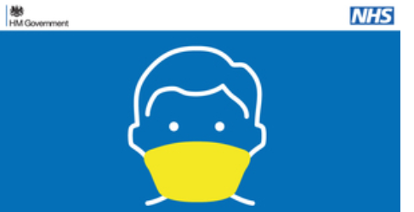
Access exemption card templates

▬▬▬▬▬▬▬▬▬▬▬▬▬▬▬▬▬▬▬▬▬▬

Working from home

To help contain the virus, office workers who can work effectively from home should do so over the winter.

Where an employer, in consultation with their employee, judges an employee can carry out their normal duties from home they should do so.

Public sector employees working in essential services, including education settings, should continue to go into work where necessary.

Anyone else who cannot work from home should go to their place of work. The risk of transmission can be substantially reduced if COVID-19 secure guidelines are followed closely. Extra consideration should be given to those people at higher risk.

▬▬▬▬▬▬▬▬▬▬▬▬▬▬▬▬▬▬▬▬▬▬

New rules for businesses

New rules for businesses were introduced from 24 September.

- Businesses selling food or drink (including cafes, bars, pubs and restaurants), social clubs, casinos, bowling alleys, amusement arcades (and other indoor leisure centres or facilities), funfairs, theme parks, adventure parks and activities, and bingo halls, must be closed between 10pm and 5am. This will include takeaways, but delivery services can continue after 10pm.
- In licensed premises, food and drink must be ordered from, and served at a table.
- Customers must eat and drink at a table in any premises selling food and drink to consume indoors, on site.
- Businesses will need to display the official NHS QR code posters so that customers can ‘check-in’ at different premises using this option as an alternative to providing their contact details once the app is rolled out nationally.

Full guidance on venues required to enforce the rule of six, NHS QR code posters and contact logs.

Businesses and organisations now face stricter rules to make their premises COVID secure.
  - A wider range of leisure and entertainment venues, services provided in community centres, and close contact services will be subject to the COVID-19 Secure requirements in law and fines of up to £10,000 for repeated breaches.
  - Employers must not knowingly require or encourage someone who is being required to self-isolate to come to work.
  - Businesses must remind people to wear face coverings where mandated.
The spread of the virus is also affecting the ability to reopen business conferences, exhibition halls and large sporting events, so this will not happen from 1 October.
▬▬▬▬▬▬▬▬▬▬▬▬▬▬▬▬▬▬▬▬▬▬
When to get a COVID-19 test and when not to
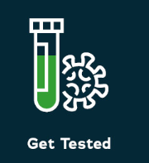
There are two different COVID-19 tests. One tells you if you have COVID-19 now, the other tells you if you’ve had it before.
When to get a test
If you have the following COVID-19 symptoms you should get a test done as soon as possible:
- a high temperature
- a new, continuous cough
- a loss or change to your sense of smell or taste
Get a free NHS test to check if you have COVID-19.

Stay at home if you have symptoms
If you are getting a test because you have symptoms and anyone you live with must self-isolate until you get your result. This also applies to anyone in their support bubble (where someone who lives alone - or just with their children - can meet people from one other household).
You must also self-isolate if you cannot get a test.

Care home residents or staff

There’s a separate testing service for care home residents or staff members. You can still get tested even if you do not have symptoms.

Antibody testing to check if you’ve had coronavirus before
Antibody tests are to help the NHS and scientists learn more about who has already had the virus and how it has spread in the UK.
Free NHS antibody tests are only available to some NHS and care home staff. You’ll receive an invite by email if you’re eligible.
Find out more about antibody testing.
When not to get a test
You should only get a test if they have COVID-19 symptoms or have been asked to get tested. As we enter the winter months there will be many colds in circulation.
You should not use the NHS testing service to get a test in order to travel to another country.
How to get a test
If you have symptoms you can have a test (swab test) to check if you have COVID-19.
You can choose to take the test:
- At a test site
- With a home testing kit

You must book a test in advance; you cannot simply turn up at a test site.
The testing service is currently experiencing high demand. If you cannot get a test appointment or the location or time are not convenient, you should try again later as appointments are released throughout the day.
Anyone who cannot get online to book a test should call 119 to book a test.

Having problems getting a test?
If you're having problems getting a test, see answers to common questions about asking for a coronavirus test.
▬▬▬▬▬▬▬▬▬▬▬▬▬▬▬▬▬▬▬▬▬▬

NHS COVID-19 app
The NHS COVID-19 app is now available and you can download it via the App Store or Google Play.
It will be used alongside traditional contact tracing, to notify users if they have come into contact with someone who later tests positive for coronavirus.
The app allows people to report symptoms, order a coronavirus test, check in to venues by scanning a QR code and it helps the NHS trace people that may have coronavirus.
It will support and enhance the NHS test and trace service and help health professionals to understand quickly if the virus is spreading in any particular area.
Businesses such as pubs, restaurants and cafes are now legally required to display a QR poster for the public to scan and log their attendance as they enter the premises. The council also has QR posters up at our public buildings, such as hubs, libraries and leisure centres.
Here’s some FAQs for businesses.
For those who don’t have the app, they can still log-in their attendance at the venue using the business’ own alternative system.
The anonymity of the person using the app is protected and nobody, including the government, will know who or where a particular user is.
The app is designed to track the virus, not individuals. It does not track an individual’s location, people are only required to in put their postcode district, which is typically shared by around 8,00 people. It uses Bluetooth technology to track time and distance between smartphone devices, so that app users who have spent time near other app users, who later test positive for coronavirus can be notified.
We are seeing COVID-19 spikes across the country so please download the app and help support the test and trace service, so together we can keep the virus under control here in Wiltshire and protect people as much as possible.
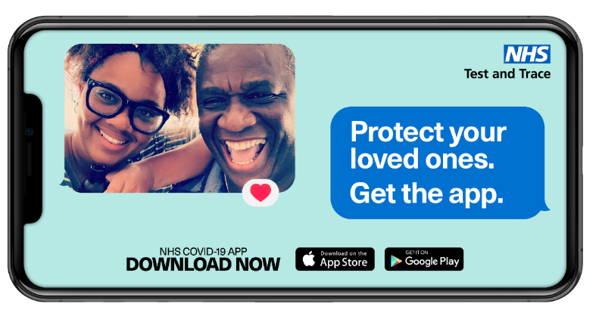
▬▬▬▬▬▬▬▬▬▬▬▬▬▬▬▬▬▬▬▬▬▬

Self-isolation - you could be entitled to COVID-19 Test and Trace support payment scheme
We all have to work together and follow the guidance as we look to keep COVID-19 under control in Wiltshire. We know that when people are told to self-isolate this can increase financial pressures at an already difficult time.
If you are required to self-isolate, a £500 payment is available if you are working and on a low income and will lose money because you cannot work from home.
To receive this payment, you must:
- have been asked to self-isolate by NHS Test and Trace after Monday, 28 September 2020 and have a unique Test and Trace number provided by the NHS
- be employed or self-employed
- have lost income by being unable to work from home while self-isolating
be receiving at least one of the following benefits:
- Universal Credit
- Pension Credit
- Housing Benefit
- Income Support
- income-based Jobseeker's Allowance
- income-based Employment Support Allowance
- Working Tax Credit
Wiltshire Council is in the process of developing a system to allow you to claim for this payment as quickly and easily as possible. The system will be live soon and the council will update you when it is. People who are eligible for this payment will be able to make a backdated claim to 28 September 2020.
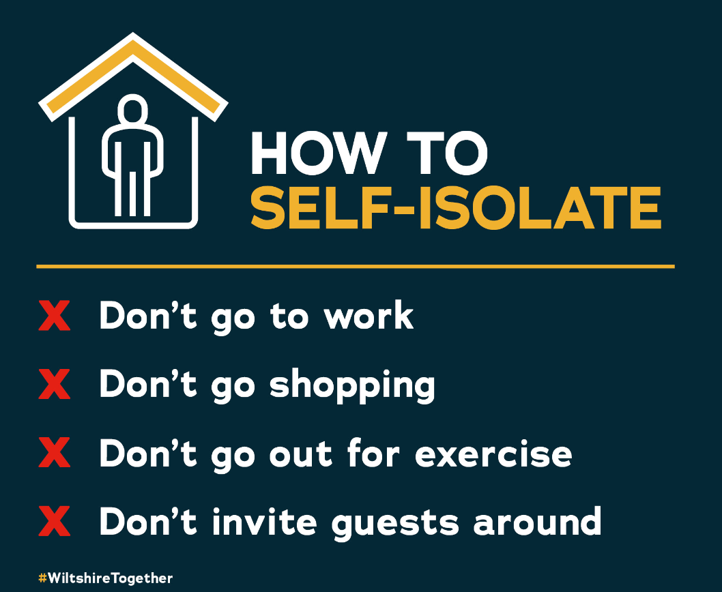
▬▬▬▬▬▬▬▬▬▬▬▬▬▬▬▬▬▬▬▬▬▬

Social media
Here are the types of messages we’ve been sharing recently:
The new NHS COVID-19 app has been launched. The app will enhance and support the test and trace service and will help health professionals to understand quickly if the virus is spreading.
Full details https://www.wiltshire.gov.uk/news-nhs-covid--19-app-launching-this-week
#WiltshireTogether

The government has announced further national measures to address the rising cases of coronavirus in England.
These include updates on:
- Face coverings
- Working from home
- Meeting people safely
Full details https://www.gov.uk/government/news/coronavirus-covid-19-what-has-changed-22-september
#WiltshireTogether

We can all help prevent the spread of coronavirus by doing the following:
Washing our hands
Wearing a face covering
Making space
If you have symptoms, please book a test immediately Right pointing backhand index http://orlo.uk/AAoHj
#HandsFaceSpace #WiltshireTogether

The new #NHSCOVID19app, now available in England and Wales, is the fastest way of knowing when you’re at risk from coronavirus.
Download now from:
Google Play Store: https://play.google.com/store/apps/details?id=uk.nhs.covid19.production
Apple App Store: https://apps.apple.com/us/app/id1520427663
Find out more: https://covid19.nhs.uk
Face coverings must be worn by customers in shops, supermarkets & shopping centres.
Full guidance on where else face coverings are compulsory, exemptions & how to make your own. https://www.gov.uk/government/publications/face-coverings-when-to-wear-one-and-how-to-make-your-own/face-coverings-when-to-wear-one-and-how-to-make-your-own
#WiltshireTogether
Recommended social media accounts
The following Twitter accounts are regularly posting out the latest factual advice and information related to COVID-19:
- Wiltshire Council
- Public Health England
- Department of Health and Social Care
- NHS England
- Wiltshire Police
- Dorset and Wiltshire Fire & Rescue Service
- NHS Bath and North East Somerset, Swindon and Wiltshire Clinical Commissioning Group
- Swindon Borough Council
- Foreign Office

▬▬▬▬▬▬▬▬▬▬▬▬▬▬▬▬▬▬▬▬▬▬
Local Outbreak Management Plan (LOMP)
Wiltshire Council has published its plans to help the county respond quickly and effectively should there be a local COVID-19 outbreak.
The Wiltshire Local Outbreak Management Plan (LOMP) sets out the approach for managing COVID-19 outbreaks locally to protect residents and support the most vulnerable.
The LOMP builds on local expertise and effective health protection processes that are already in place, and outlines how the council and partners will positively engage with the public so they're fully aware and supportive of the crucial part they have to play in the process.
The council will work with the Government to support test and trace services in local communities, taking a place-based approach to containing the spread of the infection as much as possible.
Take a look at the plans:
LOMP - Full version [1.96MB]
LOMP - Summary [2.18MB]
LOMP - Condensed [352.41KB]

LOMP posters and animation
The council has produced several posters and a short animation designed to inform people about what they need to do to prevent a rise in COVID-19 cases and further local restrictions.
Please feel free to share these posters and animation
Download the posters
Download the animation
▬▬▬▬▬▬▬▬▬▬▬▬▬▬▬▬▬▬▬▬▬▬
Keep up to date
We issue regular e-newsletters to residents and the business community with the latest COVID-19 information and guidance.
If you haven’t already signed up to receive these newsletters you can sign up via this link.
▬▬▬▬▬▬▬▬▬▬▬▬▬▬▬▬▬▬▬▬▬▬
Useful links:
Wiltshire Council COVID-19 page https://www.wiltshire.gov.uk/public-health-coronavirus
GOV.UK Coronavirus (COVID-19) https://www.gov.uk/coronavirus
NHS Coronavirus (COVID-19) https://www.nhs.uk/conditions/coronavirus-covid-19/
▬▬▬▬▬▬▬▬▬▬▬▬▬▬▬▬▬▬▬▬▬▬

