This months Clergy letter is by Rev. Mark Windsor

During the period of lockdown we have also been locked out of our churches. I don’t think I ever envisaged, as a Vicar, having to reinforce the message that our buildings were closed to people going in. How do we reconcile this seemingly incompatible sign with the message that the church is open? Does a locked door represent an immovable barrier in drawing people into God’s presence? How do we get round it? “On the evening of that first day of the week, when the disciples were together, with the doors locked for fear of the Jews, Jesus came and stood among them and said, “Peace be with you!” After he said this, he showed them his hands and side. The disciples were overjoyed when they saw the Lord. (John 20:19-20) Jesus did not need to find a way to get round the barrier of the locked door to meet with his followers. John tells us that he came and stood among them. Hence we do not read later on of his disciples discussing the time when Jesus picked the lock and appeared like a thief in the night amongst them; or of them reflecting on the moment when he showed his hands and side after shoulder-charging the door open. The locked door wasn’t a barrier to Jesus then and locked doors are not are barrier to God meeting with us by his Spirit now. Indeed if you read about Jesus’ life and ministry in the Bible you discover that there were many other barriers for us that could not hold him. After his triumphal entry and demonstration of divine authority on that occasion comes a moment of tender humanity, as Jesus shows them his hands and side. It is a reminder that God in his great power draws near us and God in his great tenderness draws alongside us. In the joy of Easter comes the revelation that the risen Lord Jesus is present with us wherever we are. Our church buildings may be closed but we continue to share God’s love in joining with the excellent work within our communities to look after our neighbours in need. Our team clergy and lay ministers are available for you to contact as usual if you need our support in any way. We are preparing online services of worship each Sunday too for you partake in and view on our Team website (www.valeofpewsey.org ). There you will also find plenty of other resources to spiritually uphold and encourage you at this difficult time.
May the Lord bless you and keep you.
“Almighty Father, who in your great mercy gladdened the disciples with the sight of the risen Lord: give us such knowledge of his presence with us, that we may be strengthened and sustained by his risen life and serve you continually in righteousness and truth”
Rev Mark Windsor

NORTH NEWNTON, HILCOTT & BOTTLESFORD
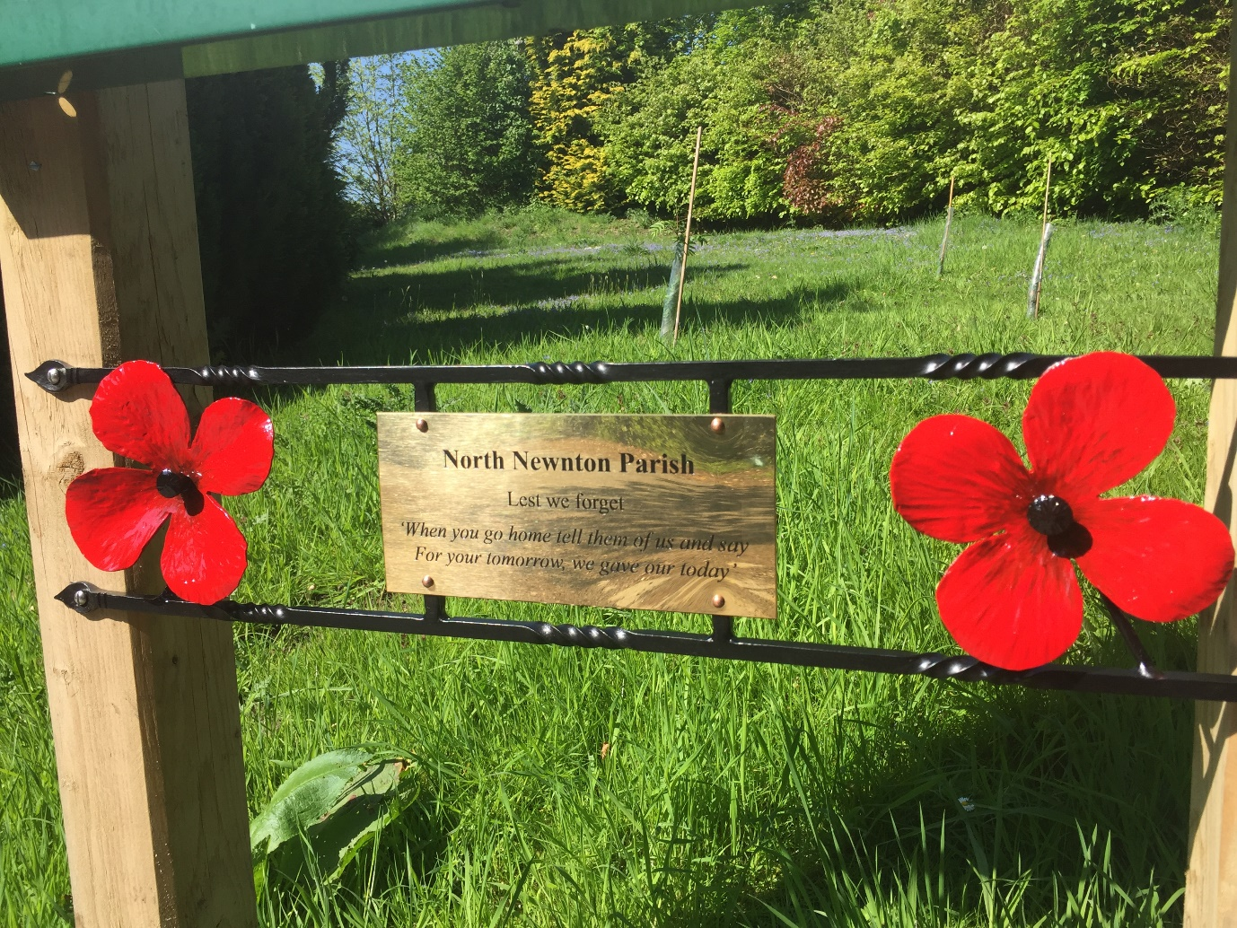
'Lest we forget' ......there is a small new sign, beside the memorial trees, near the Seven Stars
Small, in-formal gatherings popped up (at social distance of course) on VE Day; around the pond at Hilcott, the top of Bottlesford and in Gores Lane. The Last Post was played on the cornet and' Its a long way to Tipperary' on bagpipes! Special memories in these strange times. Hopefully by the time VJ Day arrives we can have a proper celebration!
Despite church buildings still being officially closed, CHURCH is to be found online with a Sunday Service on the Vale of Pewsey Team website. We will open St James ' as soon as we have permission. Work has been carried out at the Cemetery; clearing overgrown shrubs etc, allowing more light in and much needed extra space. The expense has been shared between the Church and Parish Councils. When tending graves please take waste material home. We removed six sacks full! A bin is provided for green waste.
VILLAGE HALL NEWS - We have had a Project Team meeting this month, and can make some progress re planning, although the grant situation is on hold, with all grant money from The National Lottery and other funders going towards the COVID 19 funds for charities. We are keeping the hall and environs looking tidy, so it does not look abandoned at this difficult time!
PARISH COUNCIL - Firstly a “thanks to all COVID-19 volunteers” who have been helping those self-isolating with prescription collections, food collections etc., despite the terrible situation the community is really pulling out all the stops! Cllr Kate Boulter has been one of our main Volunteer Co-ordinators and will continue with this role but unfortunately has resigned from the Parish Council after 4 years of service, we thank her sincerely for all the time and help she has given to us. On that note, anyone looking to be part of the Parish Council please contact the Clerk (clerk@nnpc.org.uk) or tel 07979 8663987.
The Parish Council was pleased to give a small donation to support Debbie Southerton’s work producing masks and scrubs for local care homes - an amazing job and a very big THANK YOU!
The Parish Council is also pleased to see the completion of Phase One of the new footpath at North Newnton leading from the roundabout at the Woodbridge Inn towards Woodbridge Close which helps with walking more safely in this hazardous area.
At the time of writing we do not know when we will be able to have our next full meeting but we can assure all residents that Parish Council Virtual meetings are taking place to maintain Parish Council business and anyone wishing to join the virtual meeting please contact the Clerk for details.

