North Newnton Parish Council
PLANNING APPLICATION

Application Ref: 19/02423/TCA

Application for Work to Trees in a Cons Area
Proposal:- Fell Silver Birch
At: St Annes Cottage, Stitchings Lane, Hilcott, Pewsey, Wiltshire, SN9 6LD

This application is being reviewed by the Parish Council. It is not intended to hold a full meeting of the Parish Council and the Parish Council response will be made by the Clerk under powers delegated to her.

If, however, any member of the public thinks that the application should be considered further by the Parish Council, please contact the Clerk within FOUR DAYS of the date of this notice. A date will then be called for a meeting which the public is welcome to attend

Plans are available to view on the Wiltshire County Council website at http://planning.wiltshire.gov.uk/Northgate/PlanningExplorer/ApplicationSearch.aspx
Signed Notice Dated 12/3/2019
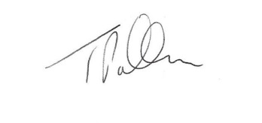
clerk@nnpc.org.uk
07554 017147

